NAME: NAVODITAA A.R
ROLL NO: 241901071

9. DEPLOYMENT OF HONEYPOTS AND ANALYSIS OF BOTNET ACTIVITIES
DATE: 25/03/2026
Aim:To deploy Honeypots and analyze botnet activities.
Procedure:
1. Log into TryHackMe and open the Introduction to Honeypots room. 2. Study the concept and purpose of honeypots in cybersecurity.
- Understand different types of honeypots and their deployment.
- Set up and observe a basic honeypot environment.
- Analyze captured data to identify botnet activities.
- Learn how honeypots help in threat detection and research.
- Complete the tasks and confirm completion.
Tasks:
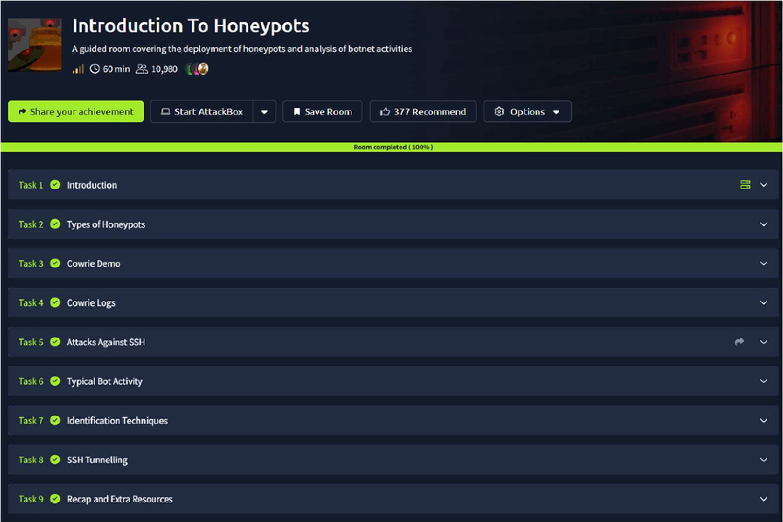
TASK 1 - Introduction
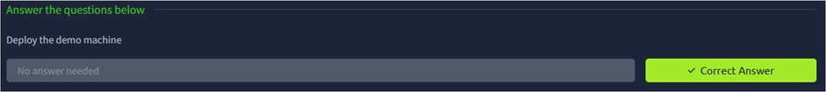
TASK 2 – Types of Honeypots
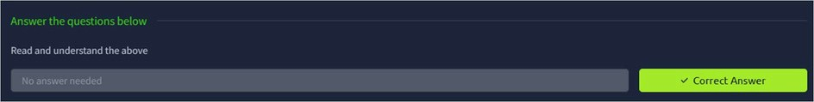
TASK 3 - Cowrie Demo
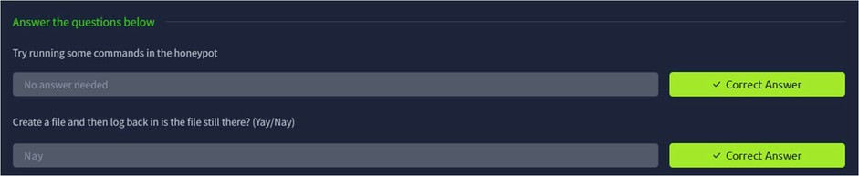
TASK 4 – Cowrie Logs
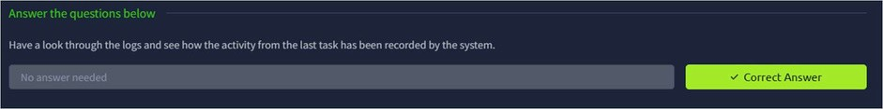
TASK 5 – Attacks Against SSH
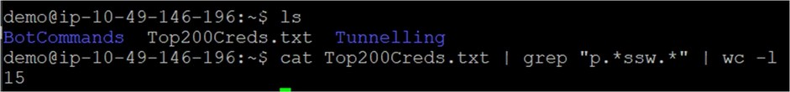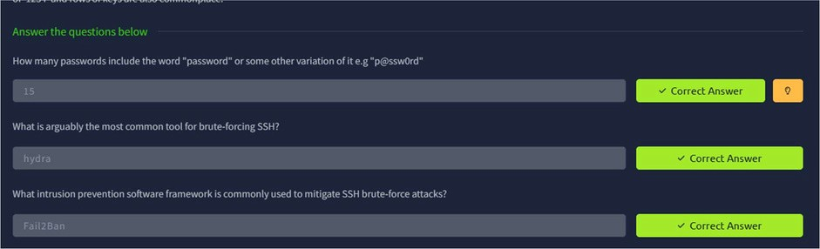
TASK 6 – Typical Bot Activity
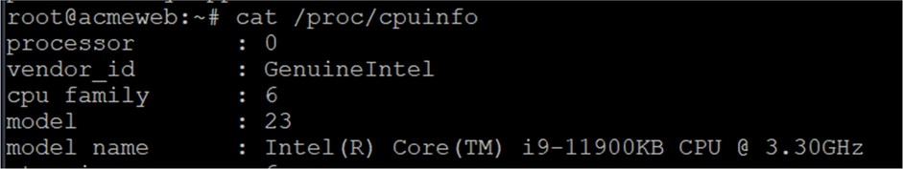
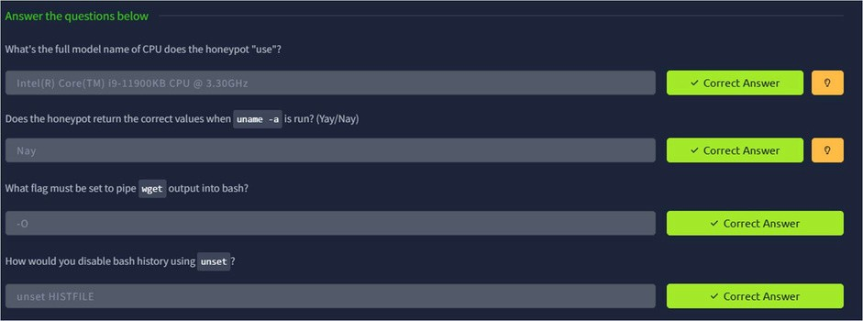
TASK 7 – Identification Techniques
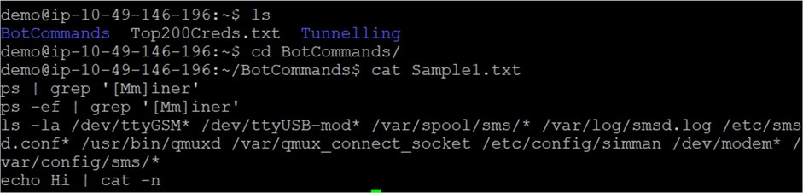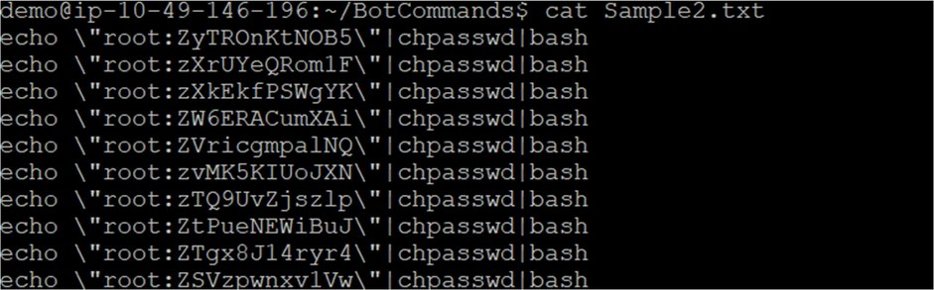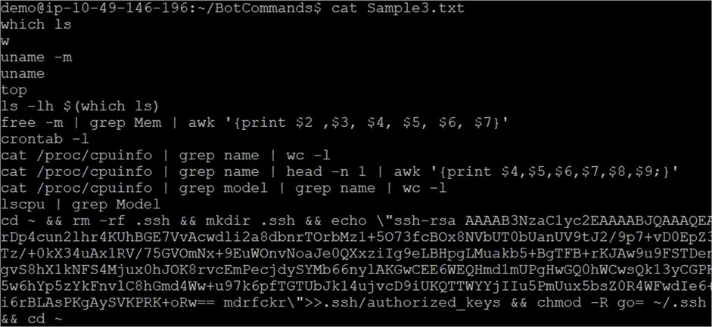
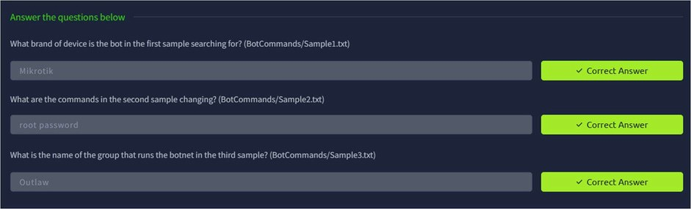
TASK 8 – SSH Tunneling
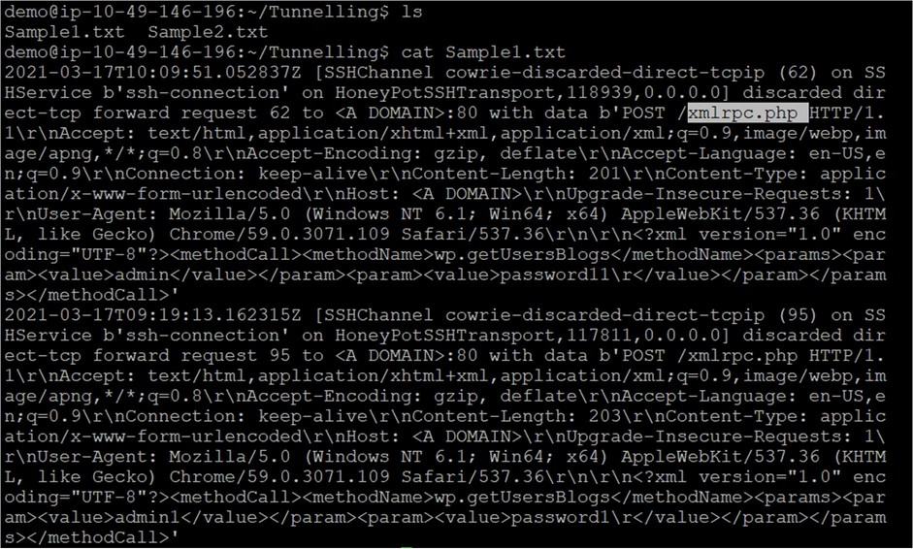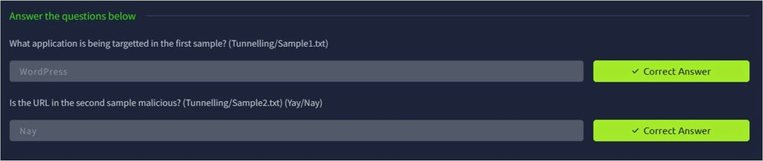
TASK 9 – Recap and Extra Resources
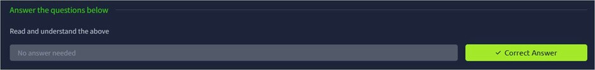
Result:
Thus the TryhackMe room Introduction to Honeypots was completed successfully.

